**MCMV group report**

**Differences between Galaxy and command line steps:**

Steps in web-based server:

* Uploading the fastQ files and executing them.

Steps in command line:

* If there is no installed, first we need to install FastQC software and then for the executing it just type FastQC and then in front of that your fastQ file.

**Samples coverage:**

WT 380-1640

RHWT 1434

RHWTD611 1241

RHWTD611R 1218

BAC 285-1640

WTD11 284-1223

WTD11R 284-1223

**Move forward or continuing filtering?**

**WT_R1**

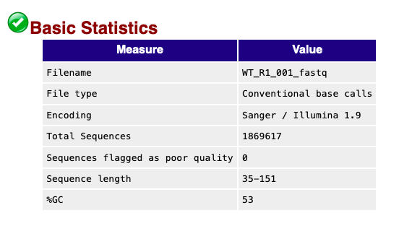

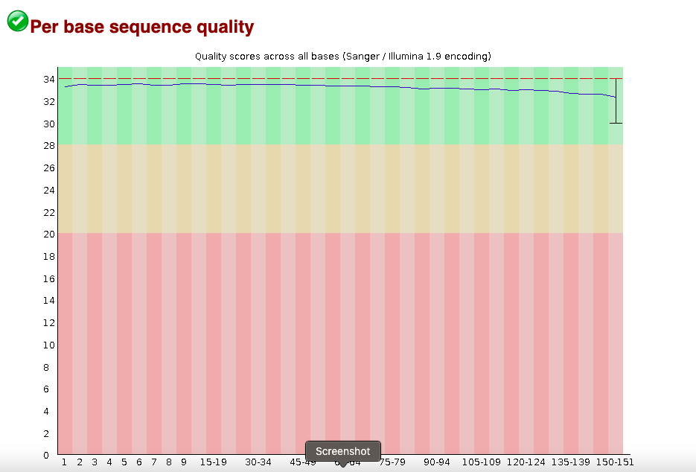

**WT_R2**

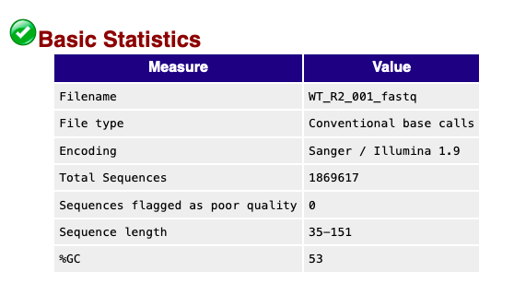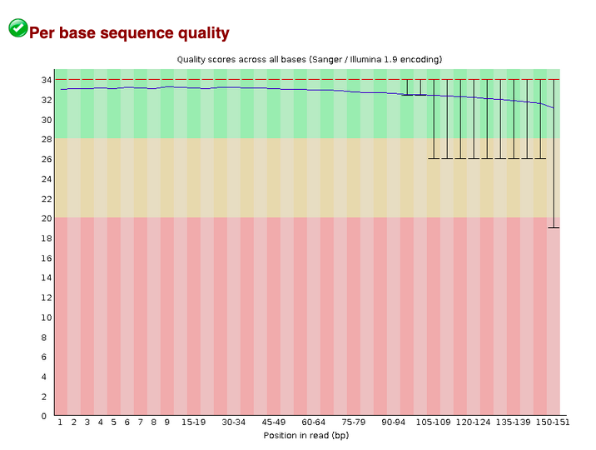

**WTD11_R1**

**WTD11_R2**

**WTD11R_R1**

**WTD11R_R2**

**RHWT_R1**

**RHWT_R2**

**RHWTD611_R1**

**RHWTD611_R2**

**RHWTD611R_R1**

**RHWTD611R_R2**

BAC_R1

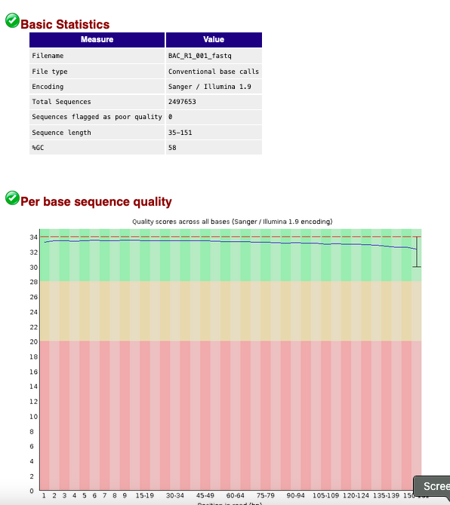

BAC_R2

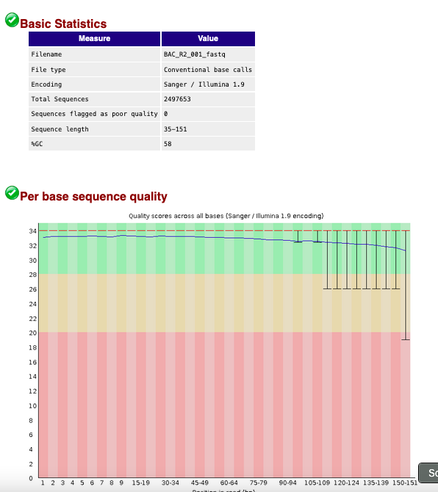

* Based on read quality and coverage we decided to move forward.